BI Warm-up Assignment

**Exercise #1 Offline Dashboards with Advanced Visualizations**

**Dashboard 1:** Fertility Rate and Life Expectancy

- According to the data, from 1980 through 2007 for Americas, which is the only country that shows an increase in fertility rate and life expectancy?

Answer: United States

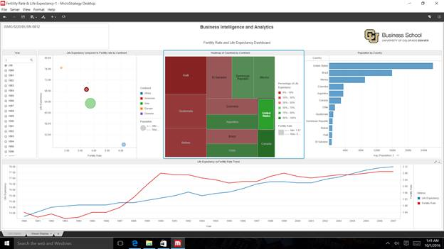

- Which country in Europe had the highest fertility rate for its continent in 1980, but gradually changed to have the lowest fertility rate?

Answer: Poland

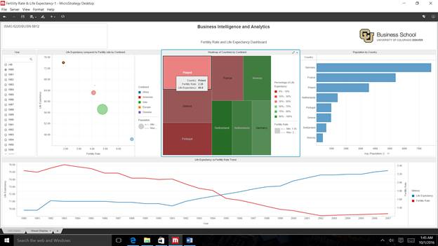

**Dashboard 2:** Region and Category Analysis

- What is the biggest selling Category for the South region?

Answer: Electronics

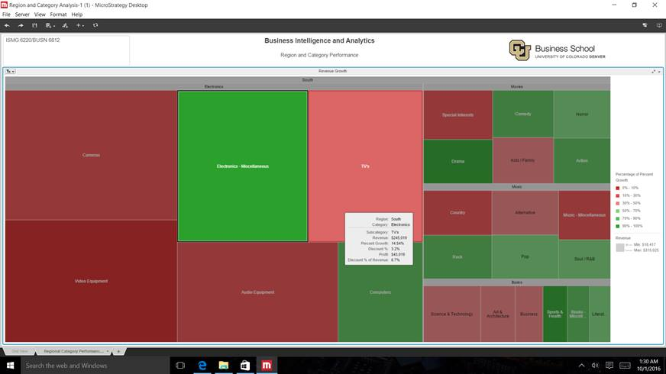

- For the South region and its largest selling Category, analyze the different metrics available and determine some of the possible causes or problematic Subcategories that could be contributing to the region’s poor performance.

Answer: Camera

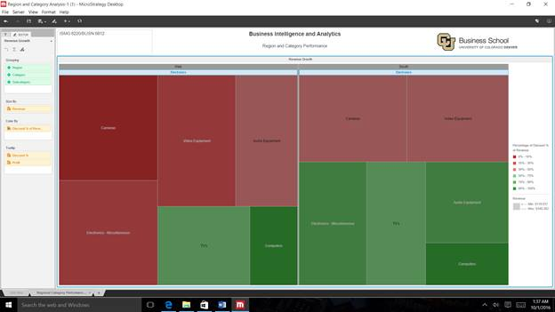

**Dashboard 3:** Hawaiian Airline performance

- If looking at the Month of September in 2009 flying between Honolulu (HNL) and Maui (OGG) what is your confidence level that you will have an on time arrival on a Wednesday, and to be safe how much time will you buffer for flight delay?

Answer: Confidence level – 45%, Buffer for flight delay – 14 minutes

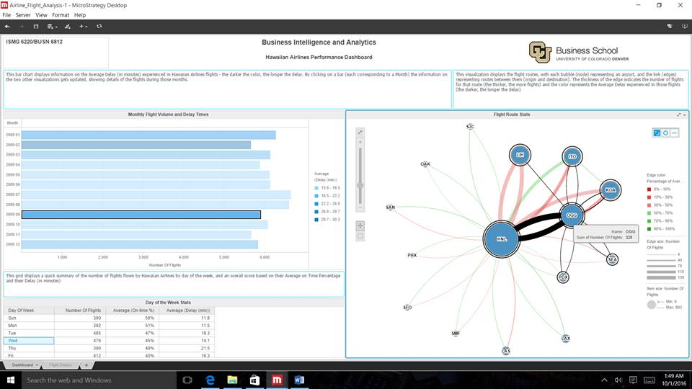

**Exercise # 2: Worldwide Carbon Emissions Scenario**

Step 19:

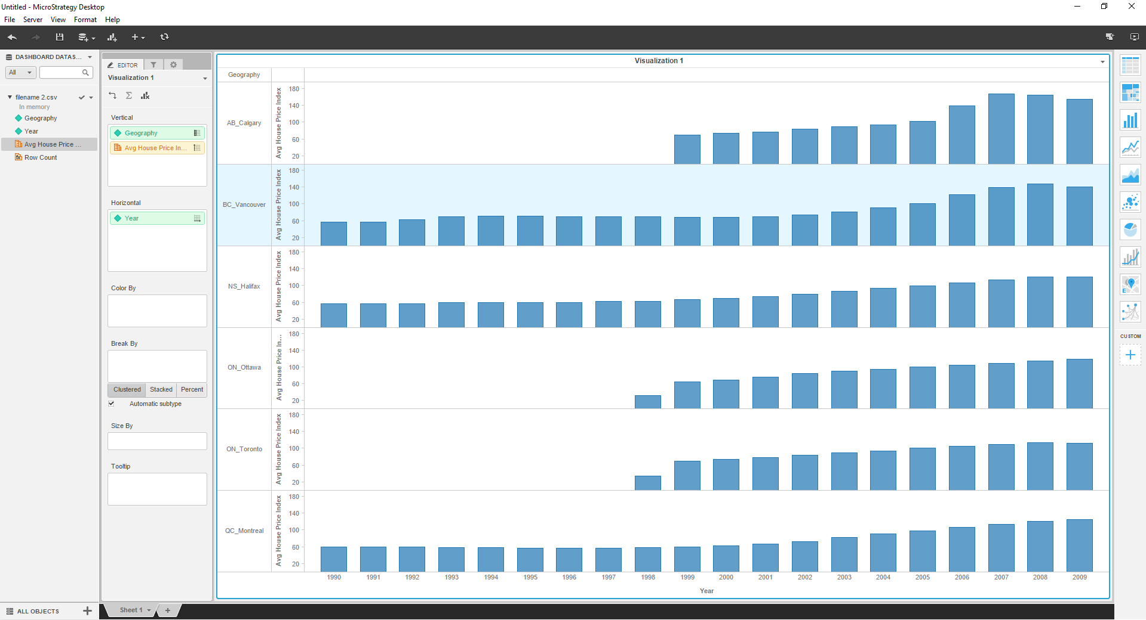

Step 36:

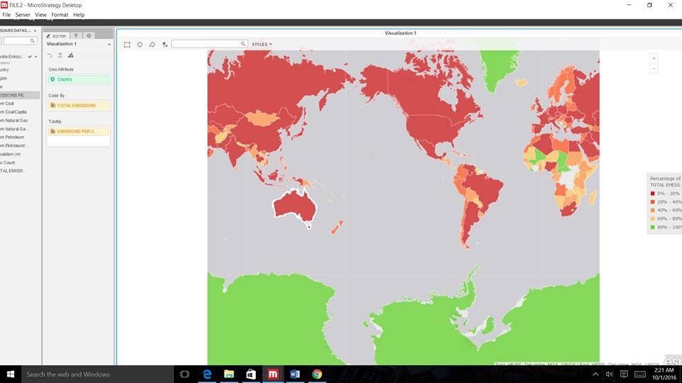

Step 14:

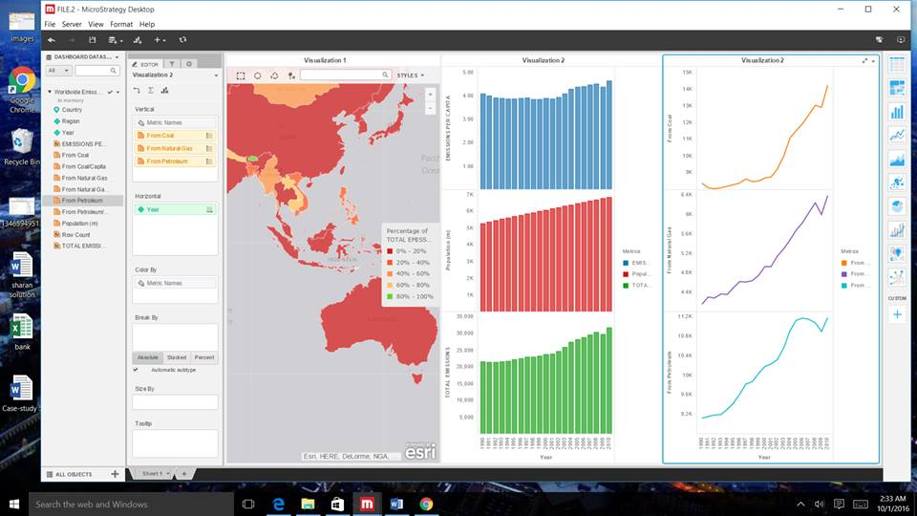

1. What are the emissions per capita of Canada?

Answer: 17.72

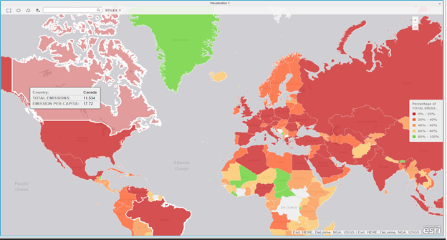

1. What is the overall trend in worldwide emissions?

Answer: It increases over the years.

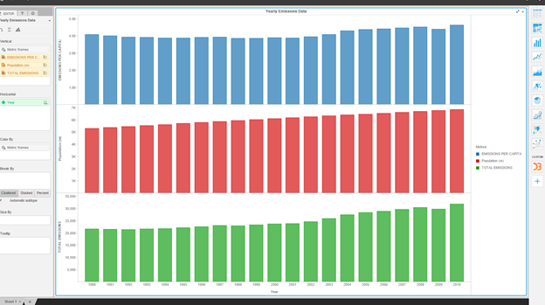

1. Notice that overall emissions declined in 2009, the only year in the total number of years surveyed that indicates emissions decreases in all three emissions sources. Why is that? What broader socio-political context might explain this single yearly decrease?

Answer: Emission fell in 2009, showing the impact of recession. Green house emissions, and carbon dioxide emission declined in 2009 and overall emissions of U.S. increased.

Canada:

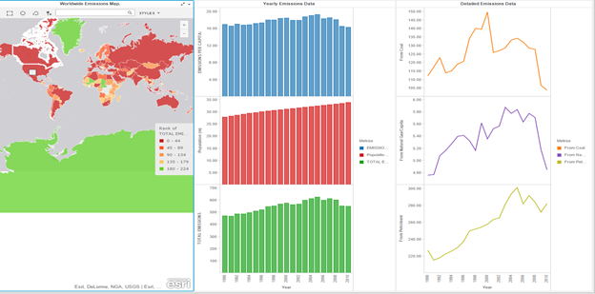

United States:

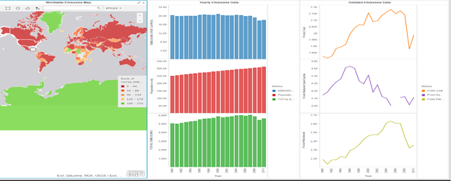

**Exercise 3: Business User Created Dashboard**

Step 17:

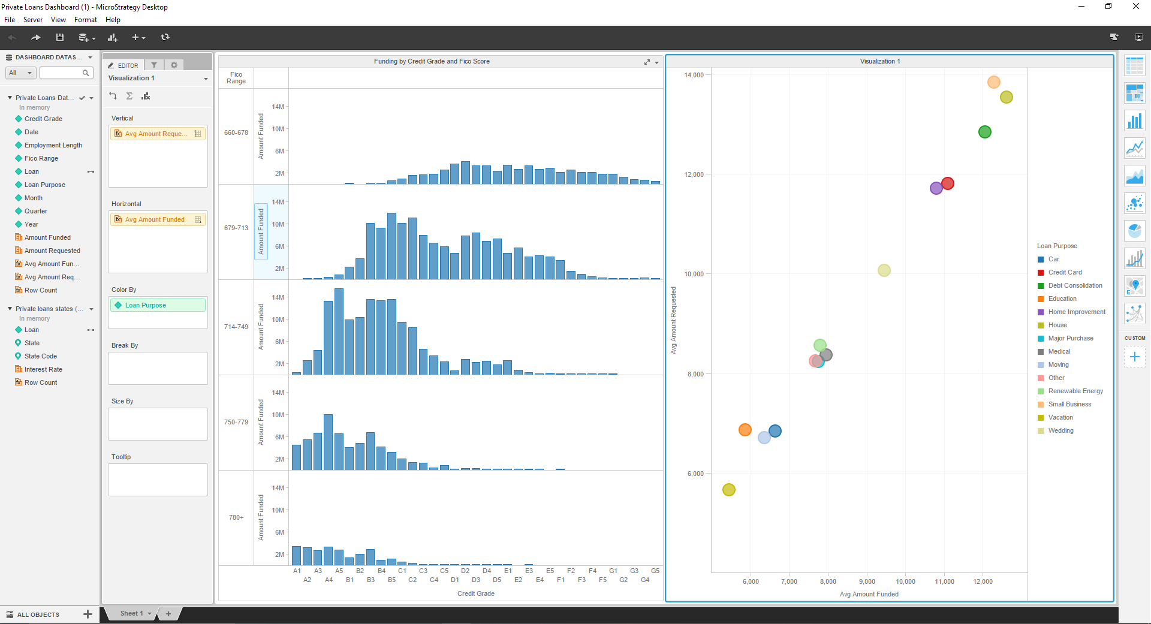

Step 30:

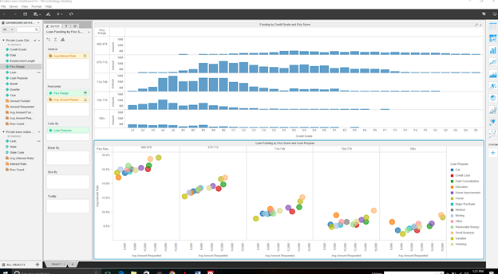

Step 51:

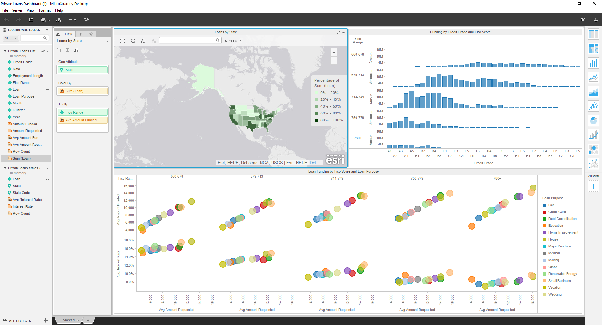

Step 63:

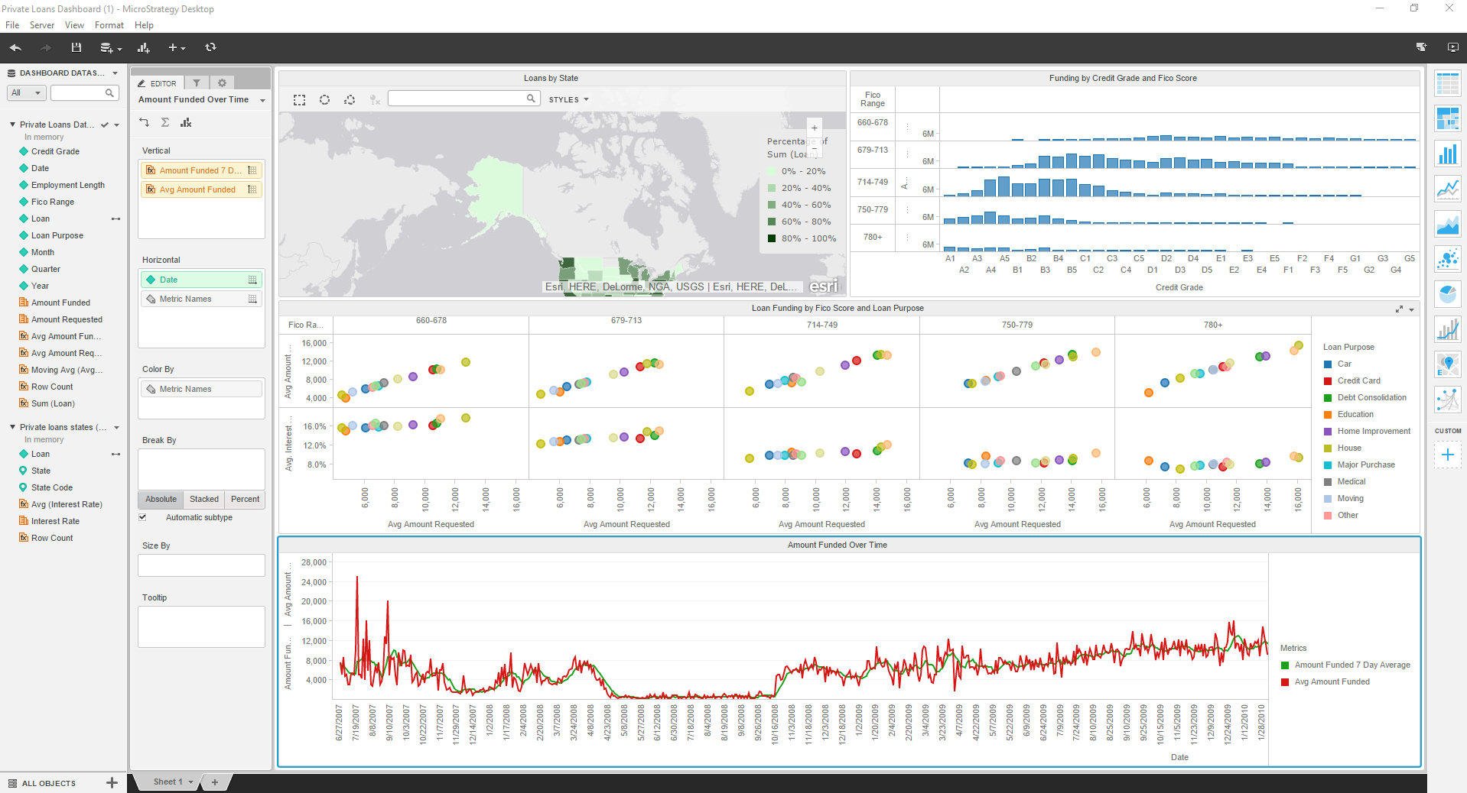

**Exercise # 4: Advanced Enterprise Data Discovery**

Step 11:

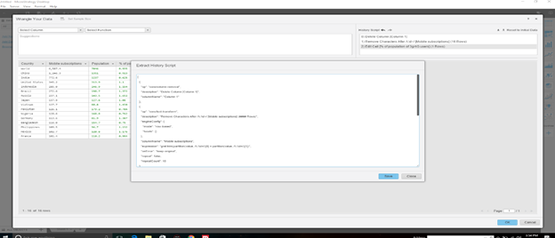

Step 24:

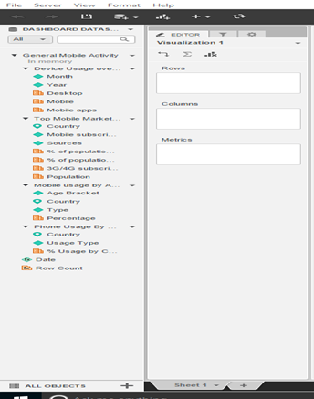

Step 30:

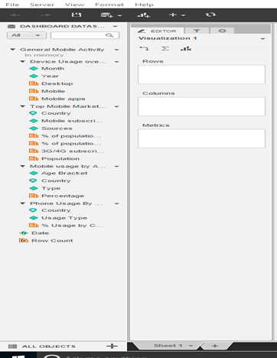

Step 34:

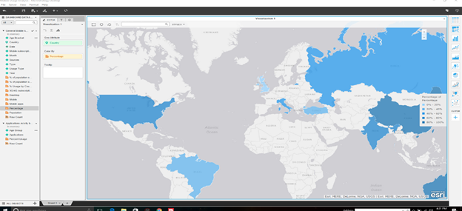

Step 43:

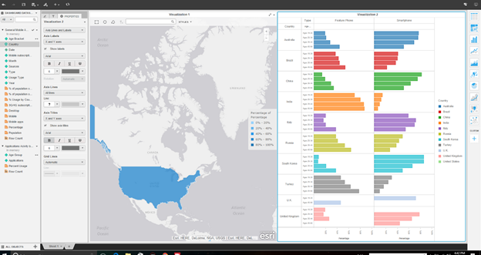

Step 57:

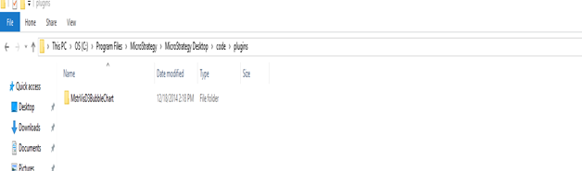

Step 71:

